***PAAREES PERFUMES***

***Christian Diors***

***FOR WOMEN***

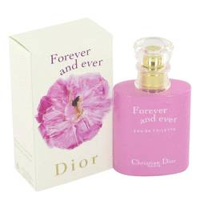

# *Forever And Ever*

***Description:***

Forever and Ever by Christian Dior Perfume. Fall in love with a feminine scent by Dior that is eternally romantic and timelessly classic. Launched by the fabulous French fashion and fragrance label in 2002, Forever and Ever is a beautiful floral composition. The exquisite women's scent blends intoxicating freesia, the exotic aqueous floral element of water jasmine and cool, spice-tinged ivy with the heart note of rose. Own the original Forever and Ever fragrance, a limited Dior edition reprised several years after its introduction.